Getting Started with React Native and Expo

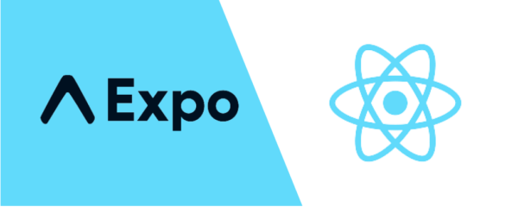

Table of Contents

1. Introduction 3

2. Overview 3

3. Installing the Development Environment 3

3.1 Computer Installation 3

3.1.1 Install Node.js 3

3.1.2 Install Expo CLI 4

3.2 Phone Installation (iOS or Android) 5

4. Creating Your First React Native App with Expo 5

4.1 Initializing the Project 5

4.2 Viewing Your App on Your Phone 6

4.3 Understanding the Project Structure 8

5. Network Configuration 8

5.2.1. Set up IP Address 8

5.2.2. Ports 9

6. Modifying Your App 9

6.1 Open and Edit Your App.js File 9

6.2 Customizing the App’s Appearance 11

7. Troubleshooting 12

8. Additional Resources 12

9. Key Terms 12

10. Glossary 13

# 1. Introduction

React Native is an open-source framework for building mobile applications using JavaScript, allowing developers to create apps for both Android and iOS with a single codebase. This approach greatly reduces development time and effort, making it an efficient choice for cross-platform app development.

Expo, on the other hand, is a platform and set of tools that simplify React Native development, especially for beginners. It offers a streamlined development experience by providing pre-configured workflows, a built-in library of components, and easy access to native device features. With Expo, you can avoid the complexities of native code, making it easier to get started and focus on building your app.

This guide is designed for people who are new to React Native and want a hands-on introduction. It will walk you through installing the necessary development environment, setting up Expo, and creating your first React Native app. By the end of this guide, you'll have a foundational understanding of how React Native works and how to use Expo to develop and run your applications efficiently.

# 2. Overview

What is React Native? React Native Combines React, a JavaScript library for building user interfaces, with the capabilities of Android or iOS platforms. It allows you to create mobile apps using JavaScript without needing to learn native languages like Kotlin, Java, Swift, or Objective-C.

Who is this guide for? It is intended for those with very basic knowledge of JavaScript and React, although prior experience is helpful but not required.

# 3. Installing the Development Environment

## 3.1 Computer Installation

You need to install two essential programs on your computer: Node.js and Expo CLI. You can use either PowerShell or the Windows Command Prompt for this process. It's recommended to run the installation as an administrator to ensure you have the necessary permissions to modify system files and correctly add global packages to the PATH environment variable.

### 3.1.1 Install Node.js

1. Visit the [Node.js download page](<https://nodejs.org/en/download/> ).

2. Download the latest LTS version suitable for your operating system (Windows, macOS, or Linux).

3. Open the downloaded file and follow the setup wizard:

- Click “Next” to proceed.

- Accept the license agreement and click “Next.”

- Choose your preferred installation location, then click “Next.”

- Ensure the "Add to PATH" option is selected (important).

- Click “Install” to begin, and then “Finish” when the installation completes.

4. Verify the installation by running the following commands in your terminal/command prompt:

**node –v** and **npm -v**

## 3.2 Phone Installation (iOS or Android)

Download the **Expo Go** app from the App Store (iOS) or Google Play Store (Android).

Ensure your computer and phone are connected to the **same Wi-Fi network** for seamless communication.

# 4. Creating Your First React Native App with Expo

## 4.1 Initializing the Project

1. Open your terminal/command prompt.

2. Navigate to your preferred folder:

**cd path/to/your/folder**

2. If you used “npx” to avoid a global installation:

- Create a new project by running:

**npx create-expo-app HelloWorld**

- This command will fetch and run the latest “create-expo-app” tool without needing a global installation.

4. Navigate into your project folder:

**cd HelloWorld**

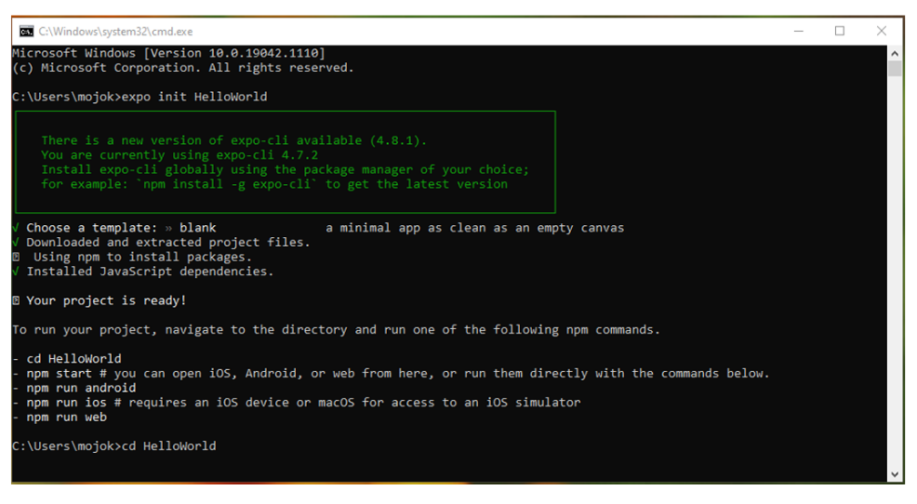

5. Start your project:

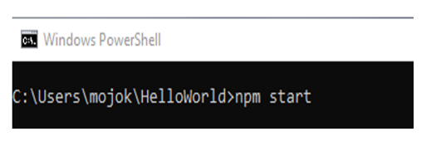 **“npx expo start”**

## 4.2 Viewing Your App on Your Phone

1. Open the Expo Go app on your phone.

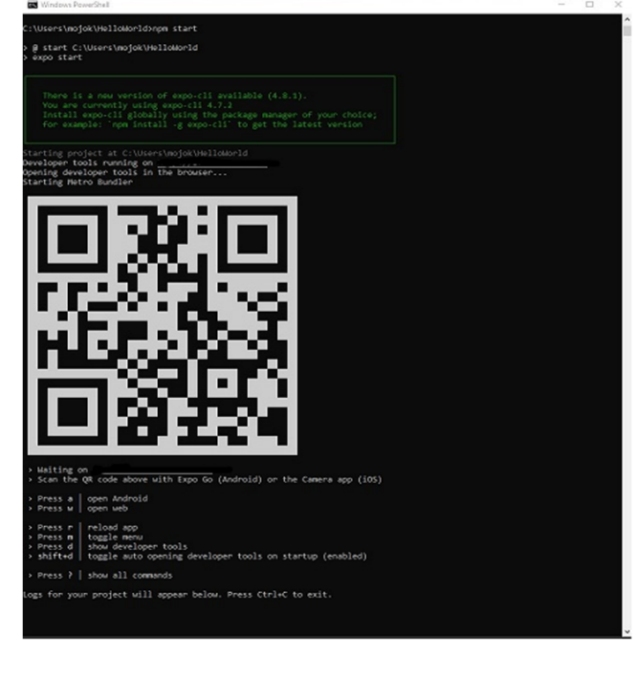2. Scan the QR code displayed in your terminal or web browser.

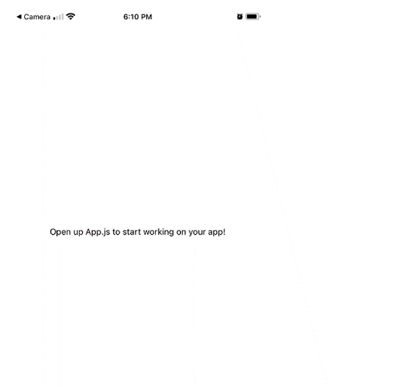3. You should see your app running on your phone.

**Note:** If the Expo Go app fails to connect to your project, especially on a public network, you may need to adjust your network settings. For detailed instructions, refer to the "Network Configuration" section.

You can access the Dev Menu to test and debug your project efficiently. To open the Dev Menu, simply shake your device if you're running the app on a physical device, or press “d” if you're using an emulator/simulator. The Dev Menu provides options such as reloading the app, opening debugger, and inspecting elements, making it easier to troubleshoot and enhance your project during development.

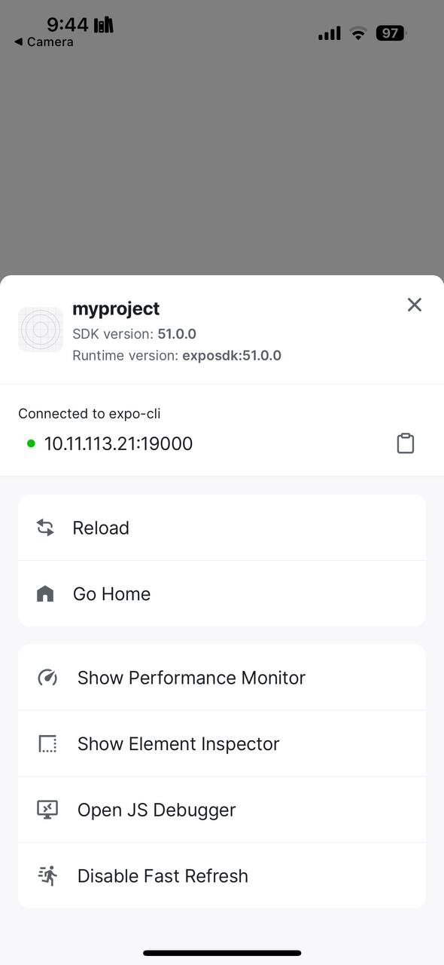

# 4.3 Understanding the Project Structure

**App.js**: This is the main entry point of your application, where you write your app's core logic and UI.

**package.json**: Contains metadata about your project, including dependencies, scripts, and versioning.

**node_modules/**: This folder contains all the packages and libraries your app needs to function, automatically managed by npm.

**assets/**: A folder to store images, fonts, and other static resources for your app.

**.expo/**: Contains Expo-specific settings and configuration files for your project.

# 5. Network Configuration

1. Make sure your device is on the same network as the server, and
2. that you have granted Expo Go the Local Network permission in the Settings app, or
3. try using the tunnel connection type.

“**npx expo start --tunnel**”

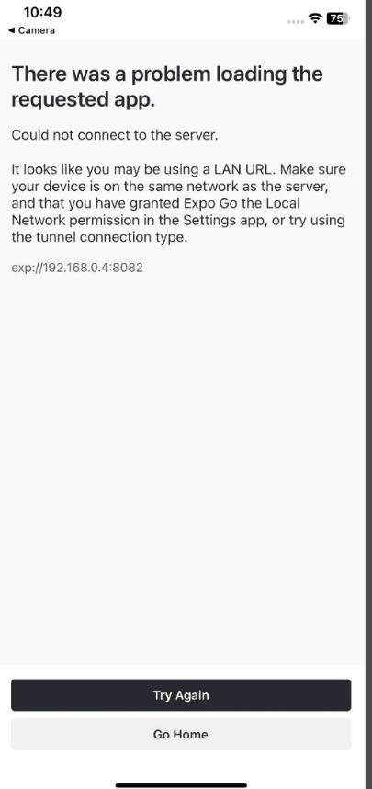

### 5.2.1. Set up IP Address

If you want to set a fixed IP address for your React Native project, follow these steps:

1. Create or edit the “metro.config.js” file in your project root and add the following configuration:

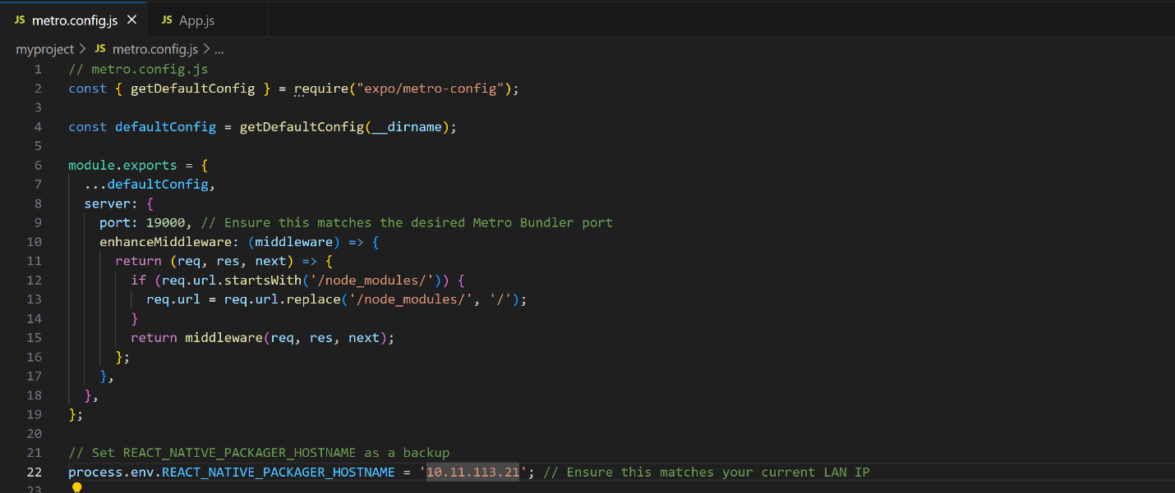

2. Set the “REACT_NATIVE_PACKAGER_HOSTNAME” environment variable by running the following command in your terminal:

“**export REACT_NATIVE_PACKAGER_HOSTNAME=<your-computer-ip>**”

Replace “<your-computer-ip>” with your actual IP address, for example, “192.168.1.10”.

### 5.2.2. Ports

The Metro Bundler starts working by default with “localhost” on port 8081. If it doesn't work, you can switch to using your computer's IP address with port 19000, which is commonly used by the Expo development server for better connectivity with your device.

| **Port** | **Used By** | **Purpose** |
| --- | --- | --- |

|  |  |  |
| --- | --- | --- |
| 8081 | React Native Metro Bundler | Serves the JavaScript bundle and handles live reloading for React Native projects. |

|  |  |  |
| --- | --- | --- |
| 19000 | Expo Dev Server | Main server for serving JavaScript code to the Expo Go app. |

|  |  |  |
| --- | --- | --- |
| 19001 | Expo WebSocket Server | Enables real-time communication, debugging, and logs for Expo projects. |

|  |  |  |
| --- | --- | --- |
| 19002 | Expo Developer Tools UI | Hosts the web-based Expo Developer Tools interface. |

# 6. Modifying Your App

## 6.1 Open and Edit Your App.js File

1. Open “App.js” in a text editor (e.g., Visual Studio Code, Notepad).

2. Find the line with “<Text>” containing "Open up App.js to start working on your app!".

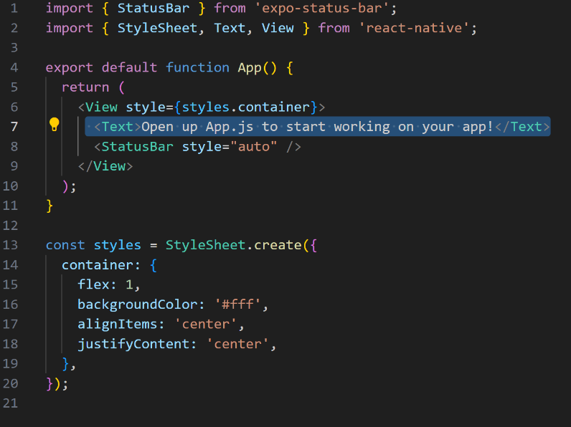

3. Change this text to "Hello, world!" and save the file.

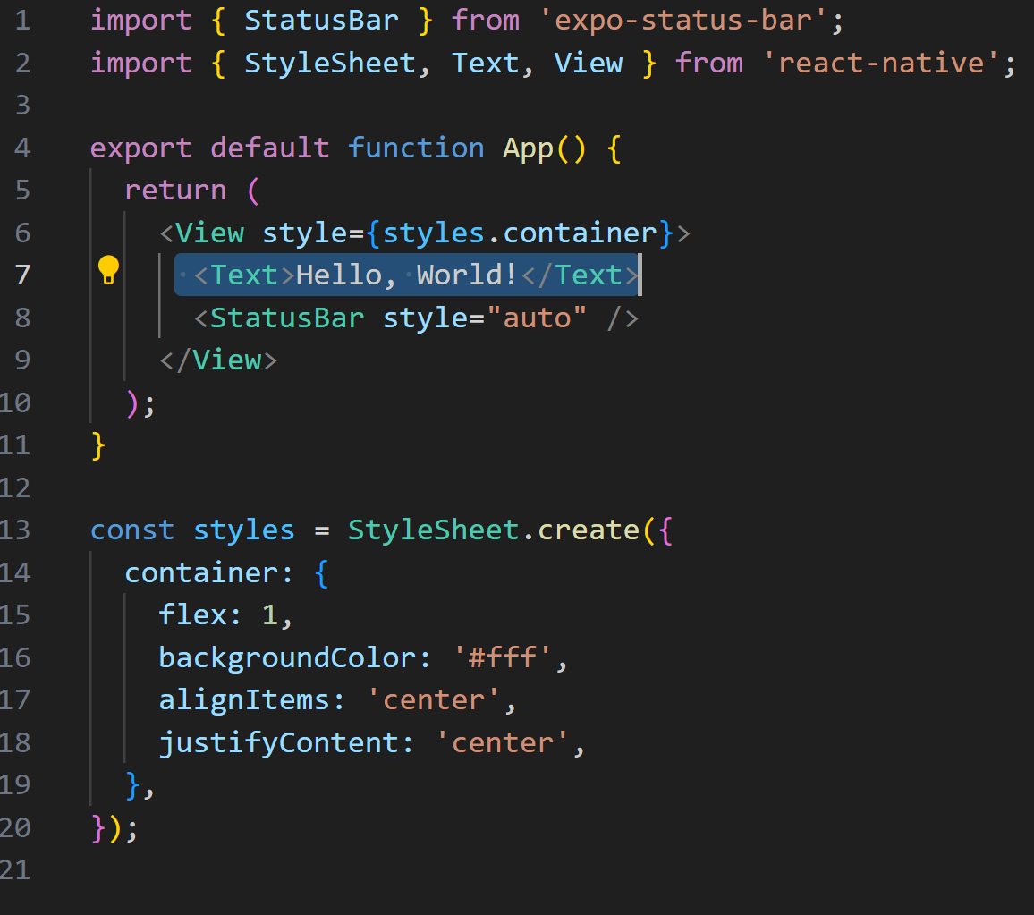

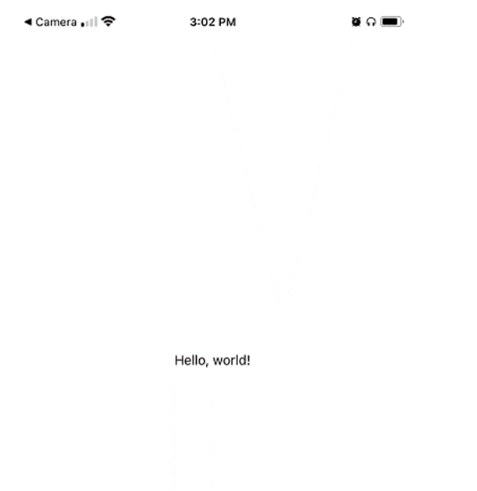You should see the changes reflected in your app automatically.

## 6.2 Customizing the App’s Appearance

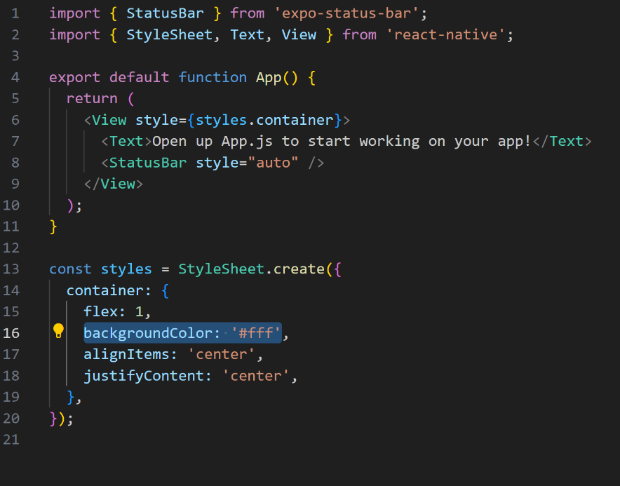1. Locate the “backgroundColor” property within the “styles” section.

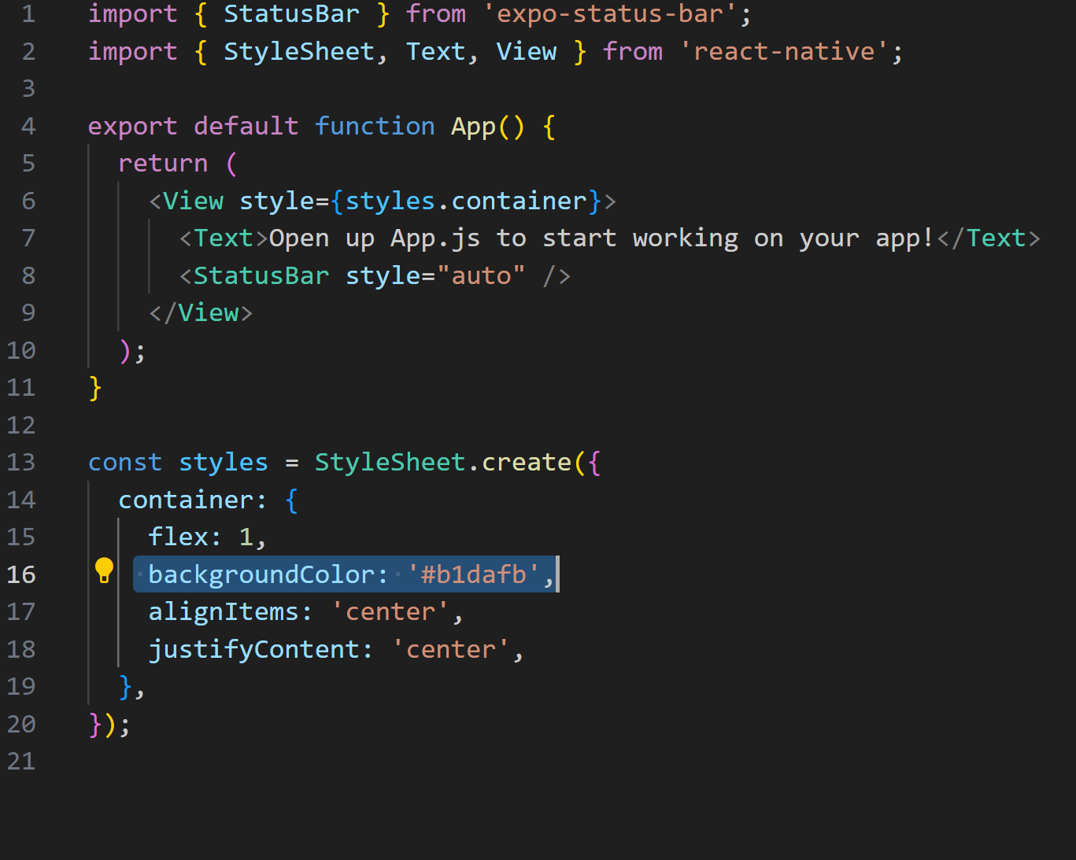2. Change “'#fff'” to “'#61dafb'” (React Native blue) and save the file.

3. Check the updated appearance on your phone.

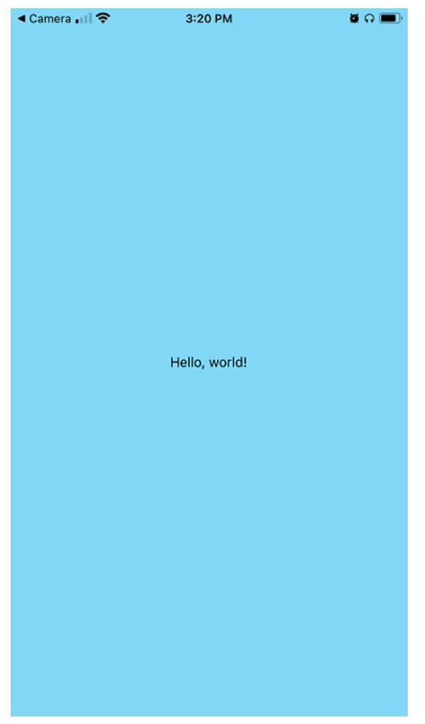

# 7. Troubleshooting

If you encounter issues during setup, refer to the React Native [Setup Troubleshooting Guide] (https://reactnative.dev/docs/troubleshooting).

Common issues include:

Expo CLI not recognized: Ensure you installed it with “npm install -g expo-cli” and restart your terminal.

# 8. Additional Resources

[React Native Documentation] (<https://reactnative.dev/docs/getting-started> )

[JavaScript Tutorials by Mozilla] (<https://developer.mozilla.org/en-US/docs/Web/JavaScript> )

[React JavaScript Library] (<https://reactjs.org/> )

[Expo Documentation] (<https://docs.expo.dev/>)

# 9. Key Terms

**Command Prompt:** A text-based interface used to run commands on Windows.

**Terminal:** A similar tool to the command prompt, used in macOS/Linux.

**LTS:** Long-Term Support, which refers to software versions that receive updates and support for a longer period.

# 10. Glossary

**Node.js:** JavaScript runtime environment.

**JSX:** JavaScript XML syntax used in React.

**Props:** Custom properties for React components.

**State:** Data that controls a component's behavior in React.